Community Development Foundation

Community First Monitoring
Report- Guidance Notes

What is monitoring?

Monitoring is about collecting information that will help you answer questions about your project. It is important that this information is collected in a planned, organised and routine way. You can use this information to report on your project and to help you evaluate.

All groups funded by Community First are required to provide monitoring information as part of their grant contract. This helps CDF to find out:

• how your project went and whether it went according to plan

• how it helped meet the programme objectives to support initiatives in the neighbourhoods identified.

• the final costs of the programme,

These guidance notes will explain what you need to do.

How we monitor the success of your project

There are two elements of reporting for this programme, you need to do both:-

1. TO CDF: Once your project has been completed we will ask you to complete and return a monitoring form. This is an online form and the link to the form is on the following page. This report should be submitted to us no later than four weeks after you‟ve finished your project.

2. To your local Community First panel: We also ask you to provide information and updates about your project to your local panel, to be used on their Community First website. This can take
the form of photographs, case studies, etc.

1
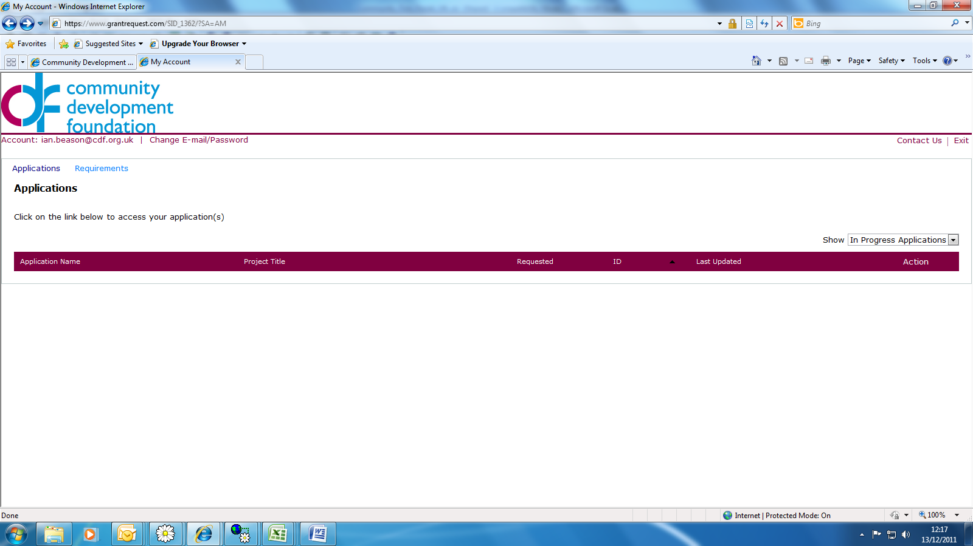The online form

Log on to the system using the link below, which will take you to your homepage.

Online account main page

Once in, click on the requirements tab, this will take you to the online monitoring form (see image above).

Please complete this form giving as much detail as you can to answer the questions.

The form is broken down into five sections; please complete all of the sections before submitting your form.

If you wish to save your form and return to it later, you can do. When you save it you are automatically sent a saved version of your form. Once you have completed all sections you can then press the submit button.

To return to a saved form

If you need to go back to a saved form please use the link below to go to the registration page, NOT the one above (which takes you to a new form):-

Online account main page

Once the form is completed you can then press „submit‟ , to send it to CDF. You will then receive an automated confirmation that your form has been submitted. Once CDF have processed your form we will write back to confirm that your panel can now begin to fund projects.
The form

Section 1 Project

This section gives you the monitoring deadline (one month after the stated project end), and also asks you to say if any of the details from the original proposal had changed. The form displays data from the application form so you can review what you said there.

Section 2 Achievements

Here you get to reflect on the successes of the project and what you achieved.

Section 3 Challenges

This is the section to identify any challenges you encountered in running your project.

Section 4 Participants

Here we want you to tell us all of the people who were involved with your project.

Section 5 Project Expenditure

In this section you need to record the final costs of the project, both how much grant you actually spent and how much match you actually made.

Unspent funds

If you did not spend the full amount then let us know the reasons why that happened.

Any money not spent will have to be returned to us. Please pay by BACS if possible using the below account details. If this is not possible then we will accept a cheque sent to the address below. Please write the name of your group and “Community First Underspend” on the remittance
advice. The cheque should be made payable to the „Community
Development Foundation‟.

Bank Natwest Bank

Branch 1 Princess Street London

Sort Code 60-00-01

Account Code 39607674

If paying by cheque please send to the address overleaf,
Finance Department
Community Development Foundation
Unit 5 Angel Gate
320-326 City Road
London
EC1V 2PT

Once you have completed all sections of the form you can then press ‘Submit’ and it will be sent to CDF. You will then be sent an email confirming submission, which will include a copy of the report you submitted for your records.

